**Course: Advance Bio Informatics**

**Module Title: Application Area of Bio Informatics**

**Module No: 90**

**Application areas of** **Bio Informatics**

Biotechnology used in Development of disease resistant plants. Food crops that produce greater yields. Golden rice engineered to be more nutritious. Genetically engineered bacteria that can degrade environmental pollutants

* Molecular medicine
* Personalised medicine
* Preventative medicine
* Gene therapy
* Drug development
* Waste cleanup
* Climate change Studies
* Alternative energy sources
* Bio-fuel
* Drought resistance crops

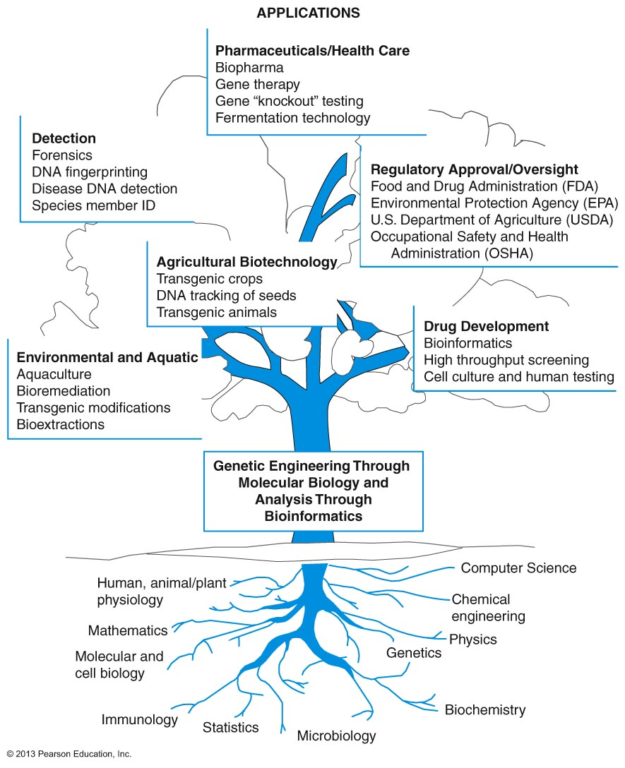

**Products of Modern Biotechnology**

|  |  |
| --- | --- |
| **Product** | **Application** |
| Blood factor VIII (Clotting Factor) | Treat Hemophilia |
| Insulin | Treat Diabetes |
| Interferons | Treat cancer and viral infections |
| Tissue Plasminogen Activator | Treat heart attacks and strokes |
| Growth Hormone | Used in cows to increase milk production |